Family Name ______________________________
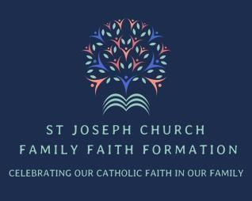
St. Joseph Church Welcome Letter
Please print, fill out and return with payment

Dear Families,

The St. Joseph Parish Family welcomes you and your children into our Family Faith Formation Program for Grades K-8. By registering your child online, you have read and agreed to the St. Joseph Church Faith Formation Handbook 2025-26 and agreed to the following payment.

Cost Per Family for children in grades K-8
1 Child $125 _____ 2 children $175 _____ 3 or more children $200 _____

Payment is due by August 31, 2025 and can be mailed or dropped off to the parish office

Make checks payable to: St Joseph Church (in memo FFF/Edge)
Mail checks to: 31 Oak St Winsted, CT 06098 attention Lindsay Rodgers

Questions
- Is your family registered parishioners at St. Joseph Parish? Yes/No/Not Sure
1a. Are you a Parishioner in another Parish? Yes/No
1b. Name of Parish you are registered with: _______________________
- What brought you to St Joseph’s Family Faith Formation? ____________________________________________________________________________________________________________________________________________________________
- Are your children in need of Sacraments? Baptism ___ First Holy Communion ____
- Can your family volunteer to help cook/prep one meal for FFF ____________________

Parent /Guardian Signature________________________________________________________

Thank you for this helpful information. We look forward to seeing you at our first meeting. If you have any questions please feel free to call me at 860-379-3369 x 6

Respectfully Yours,

Lindsay Rodgers
SJC Faith Formation Coordinator

